District Participatory Planning & Budget Guide (DPP&BG) Training
Garowe, Puntland, December 2018—Summary Report

Introduction
This 3-day training and validation was designed to provide participants with knowledge and familiarity with the new District Participatory Planning & Budget Guide (DPP&BG) training modules, as well as an opportunity for a final review so that the modules could then be validated and translated into Somali. In addition, the training provided an opportunity for participants to have input into the content of the new Audit/M&E training module, to be developed in early 2019.
Training Overview
The training was held at Grand Hotel in Garowe, from 27-29 November 2018, with approximately 40 participants in attendance. Participants included District Planning Directors and Administration and Finance Directors, as well as MOI Capacity Building consultants, and other MOI staff with an involvement in JPLG activities. See Annex 1 for the 3-day training program, and Annex 2 for a list of participants.
The objectives of the training/validation were as follows:
- To review and discuss the new draft DDF and Annual Planning & Budgeting modules as part of the DPP&BG.
- To validate these modules, and identify any changes needed.
- To discuss and plan for the new Audit/M&E module, as part of the DPP&BG.
The training aimed to be as practical as possible in order to both familiarise participants with the material, while at the same time give them an opportunity to suggest any final revisions.
Day 1 focused on the DDF module. This module was developed based on the previous PEM 2. Planning Module, but with new information incorporated as a result of consultations from the PEM review process in 2016-17, and a DDF Reflections workshop conducted in May 2017. Some of these new areas included an emphasis on harmonised planning in Puntland, the inclusion of Local Economic Development as part of the DDF, more focus on DDF monitoring, and some practical tips on DDF preparation, shared by experienced districts.
The methodology used was a group work process, where groups members were allocated by district, and each district having at least one MOI Capacity Development Officer to assist. Newer districts such as Burtinle and Galdogob were joined with more experienced district groups such as Bosaso and Garowe. In their groups, participants were given a specific section of the DDF module to review, and some questions to respond to regarding that section. Participants were given time to review and discuss, and then prepared their responses and presented in a plenary session after lunch. This methodology was repeated in Day 2 and Day 3, and the questions for groups for each of these days are provided in Annex 3 below.
The group work yielded some very productive results, with insightful suggestions and feedback on the draft DDF module. The day concluded with an agreement by all to validate the module, pending the changes/additions to be made by the consultant.
Day 2 focused on the Annual Planning and Budgeting module. This module is a combination of the previous PEM 3. Budgeting and Investment Programming Module and the Local Government Financial Management Manual (particularly Ch 4. Budgeting). As such, some of the steps in the process are new and unfamiliar to the participants. The morning session started with a presentation on the new Annual Planning and Budgeting process, to give all participants an overview, as well as to point out steps which were new in the process, and different from what they had experienced in the ‘old PEM’.
As on Day 1, participants worked in their same groups to review and discuss specific sections of the new module, and answer related questions (Annex 3). Again, the process resulted in productive comments and suggestions, which will be incorporated into the module. The module was validated by the participant group at the end of the day. It is expected that more training in this area will need to be conducted with district personnel in 2019, prior to the commencement of the FY 2020 local government budgeting cycle in July.
Day 3 was conducted in a slightly different way, given that there is not yet a draft Audit/M&E module. The development of this module will take place once the M&E Framework and Guidelines have been prepared. MOI/UNDP are currently in the process of hiring a consultant for this task, and once a draft District M&E Framework and Guidelines are ready, the training module can be developed accordingly. In the meantime, it was useful to conduct some group work and plenary discussion around the challenges that district participants face in conducting M&E related activities in their roles, as well as identifying what specific things they feel are important to include in the M&E Module (see Annex 3 for questions). A set of notes identifying key M&E issues will be provided to the M&E consultant to help guide their work. In terms of the Audit aspects, the existing District Internal Audit and Audit Committee Manuals will be used to guide the development of this part of the module.
Next Steps
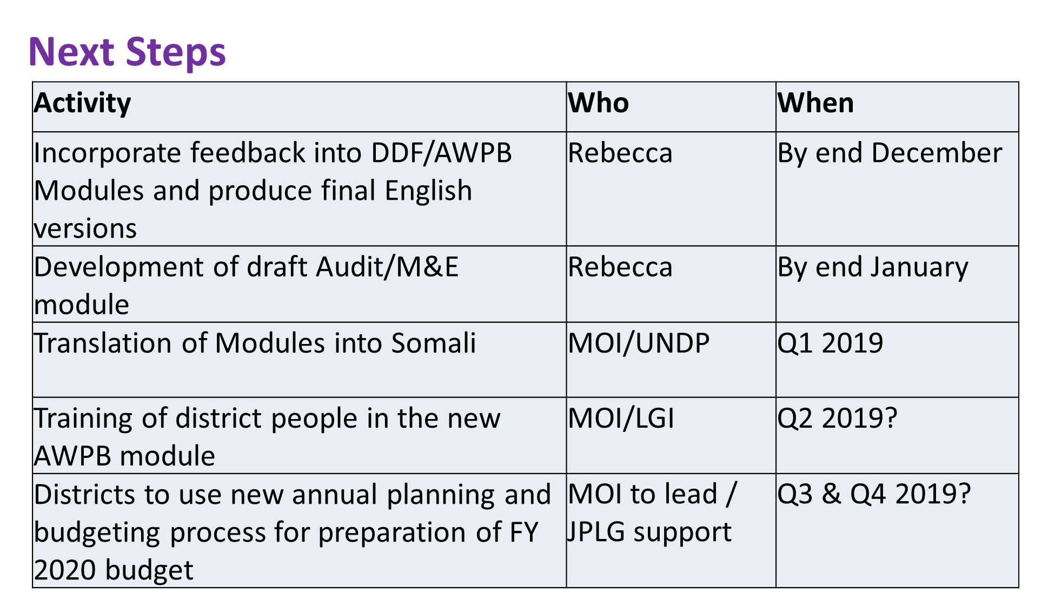
A set of suggested actions to be taken was presented, to guide the process of finalising and rolling out the existing modules, and for developing the Audit/M&E module.

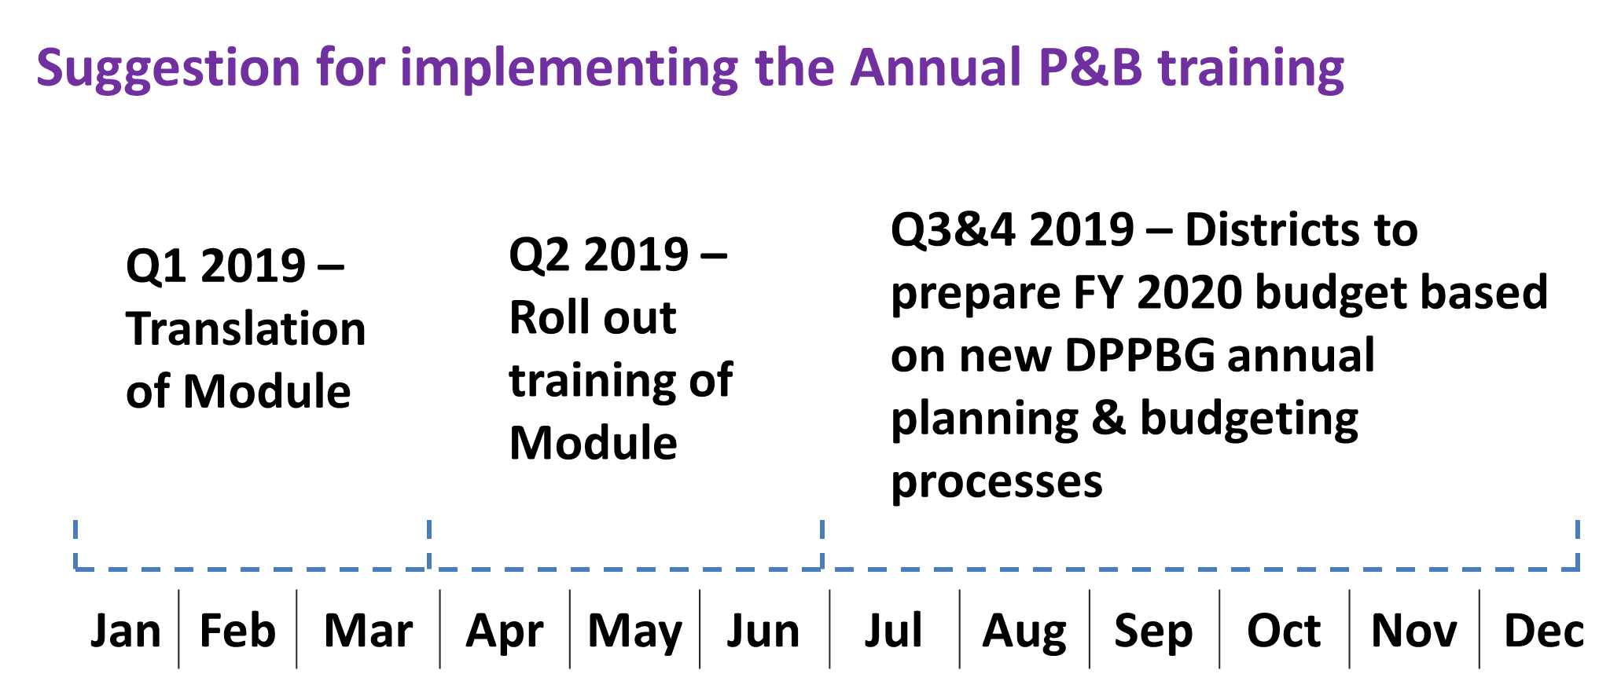

Participant Feedback and Recommendations
Participant feedback from the training/validation event was very positive, with most participants indicating they ‘agreed’ or ‘strongly agreed’ with the statements in the evaluation questionnaire (See Annex 4). The most commonly chosen words to describe the training included ‘Exciting’, ‘Motivating’ and ‘Interactive’. Some specific comments on what was learned include:
“I have gained practical lessons on how to conduct effective training about these modules to other people. Moreover, I have absorbed technical know-how about these modules.”
“The most important thing that I learned from this training was that participating is key of getting knowledge from each other, for there are participant experts, experienced persons from the districts and MOI.”
“The most important learning [in] the training, they are clarifying the DDF and annual work planning and budgeting and what additional ideas we can add.”
Suggestions for improvement included running trainings again in these areas (DDF and Annual Planning & Budgeting), for a longer time and for a wider group of district participants.
Conclusion
This training aimed to achieve validation of the two draft training modules (DDF and Annual Planning & Budgeting) while allowing opportunities for a final review of the materials. It also aimed to generate ideas about what needs to be included in the new Audit/M&E module to be developed. It is anticipated that the suggested timeline for completion and roll out of the training can be adopted by MOI/JPLG, in order to ensure these important areas of district capacity building are supported.

Rebecca Benson
Adult Education Consultant
30 November 2018
Annex 1. Training Program
District Participatory Planning and Budgeting Guide (DPPBG)
Training and Validation
Garowe, Puntland
Day 1 Tuesday 27 November
8.30-10am | - Prayer  - Welcome, Opening, Introductions  - Purpose of the ToT/Validation training  - Recap – PEM Review and DPP&BG Overview Module
10am-10.30am | Morning Break
10.30am-12pm | - Draft DPPBG DDF Module – presentation and group work
12pm-1pm | Prayers & Lunch
1pm-3pm | - After lunch Energiser  - Reporting back – groups to present findings  - Validate – either as is or with changes.
3pm-3.15pm | Wrap up and end of Day 1.

Day 2 Wednesday 28 November
8.30-10am | - Prayer and Recap from Day 1  - Short presentation on draft Annual P&B module  - Group work – reviewing and discussing the draft module
10am-10.30am | Morning Break
10.30am-12pm | Group work continued
12pm-1pm | Prayers & Lunch
1pm-3pm | - Groups present findings  - Validate the draft module either as is or with changes.
3-3.15pm | Closing and end of Day 2

Day 3 Thursday 29 November
8.30-10am | - Prayer  - Recap from Day 2  - Presentation on Audit/M&E module and process for development.
10am-10.30am | Morning Break
10.30am-12pm | - Group work – what needs to be in the new Audit/M&E module?
12pm-1pm | Prayers & Lunch
1-2pm | - Next Steps  - Evaluation  - Closing

Annex 2. List of Participants
S/No | Name | Institution | Title
1 | Mohamed Yusuf Muse | MOI | CD consultant
2 | Awil Maxamud Ali | MOI | CD Consultant
3 | Sa’ad Abdiqadir Mohamud | MOI | CD Consultant
4 | Abdishakur Mohamed Said | MOI | CD consultant
5 | Osman Ahmed Warsame | MOI | CD Consultant
6 | Yusuf Adan Ali | Bosaso | Director of Planning
7 | Abdirisaq Farah Maxamed | Garowe | Director of Planning
8 | Said Ali Mohamud | Gardo | Director of Planning
9 | Nadiro Mohamed Abdi | Galkacayo | Director of Planning
10 | Abdinasir Yasin Ali | Eyl | Director of planning
11 | Ahmed Mohamud Jama | Beyla | Director of Planning
12 | Ali Abdisamad Elmi | Galdogob | Director of Planning
13 | Faysal M Warsame | Burtinle | Director of Planning
14 | Ahmed Said Mataan | Jariiban | Director of planning
15 | Abdifitah Jama Mohamed | Galdogob | Admin & Finance Director
16 | Hirsi Mohamed Yusuf | Burtinle | Admin & Finance Director
17 | Abdiweli Ismail Yusuf | Garowe | Admin & Finance Director
18 | Bisharo Mahad Bulxan | Bosaso | Admin & Finance Director
19 | Yasin Abdi Jama | Gardo | Admin & Finance Director
20 | Abdiqadir Adan Abdi | Eyl | Admin & Finance Director
21 | Mohamud C Mohamud | Bayla | Admin & Finance Director
22 | Burhan Abdullahi Elmi | Jariiban | Admin & Finance Director
23 | Abdiqani Farah Mohamed | Galakcyo | Admin & Finance Director
24 | Mohamed Ali Nur | MOI | Director General
25 | Mohamed Mohamud Ali | MOI | Director, Local Governments
26 | Yusuf Ahmed Osman | MOI | Director of Planning
27 | Kassim Isse Ahmed | MOI | Admin & Finance Consultant
28 | Hodan Said Hassan | MOI | Head Decentralisation
29 | Hawa Isse Abdirahman | MOI | Planning Department
30 | Mohamed M Osman | MOI | Head of regional coordinator
31 | Abdisalaan M Muuse | MOI | Head of legal and policy unit
32 | Sucdi Mohamud Jama | MOI | Head of Gender Unit
33 | Deeqo Hassan Hirsi | MOI | Head of municipality budget
34 | Mohamed Said Ali | MOI | HRM
35 | Mohamed A Kaarshe | MOI | LDF consultant
36 | Abdurazak Hassan | UNDP JPLG | P Officer
37 | Nimco Hassan | UNDP JPLG | P Officer
38 | Osman M Osman | JPLG HABITAT | P Officer
39 | Abdirizak Mohamoud Ali | JPLG HABITAT | P Officer
40 | Mohamed Mohamud Ahmed | MOI | Director of Puntland LGI

Annex 3. Questions for Group Work

Day 1—DDF Module
As a group, read your assigned section of the DDF module and discuss the following:
- Is the information clear and easy to understand? If not, identify improvements to be made.
- Is there anything to be added or changed in your section? Please make suggestions.
- The Questions for Discussion – will they prompt useful discussions? Do you have any other suggestions?
- Any other comments or suggestions?

Day 2—Annual Planning & Budgeting Module
As a group, read your assigned section of the module and discuss the following:
- Does your section contain any new activities in the planning & budgeting process? If yes, how easy or difficult do you think it will be for districts to start implementing these new activities over time? Why?
- Is there anything in your section that is unclear, or causing confusion?
- Is there anything to be added or changed in your section? Please make suggestions.
- The Questions for Discussion – will they prompt useful discussions? Do you have any other suggestions for questions?
- Any other comments or suggestions?

Day 3—Audit/M&E Module
Read and Discuss the DDF Monitoring Framework for your district.
- For each column, what was challenging to prepare and why? For example: Objectives? Baseline? Indicators? Targets? Means of Verification?
- What do you think is important to include in the new M&E module?
- What else needs to be monitored in your district?

Annex 4. Evaluation Questionnaire
1. Please read the statements below about the DPPBG training and indicate with a which statement most closely represents your opinion:
 | Strongly Agree | Agree | Half/ Half | Disagree | Strongly Disagree
1. The training/validation has given me a better understanding of the new DDF module.
2. The training/validation has given me a better understanding of the new Annual Planning & Budgeting module.
3. The training materials were clear and easy to understand.
4. I feel confident that I can explain the DDF process to other people, as a result of this training.
5. I feel confident that I can explain the annual planning and budgeting process to others, as a result of this training.
6. I feel confident that I can apply what I have learned in this training back in my workplace.

2. Which of the following words would you use to describe this training? Please circle your choices (you can choose more than one).
Exciting Interactive Motivating

Boring Ineffective Confusing

3. What was the most important thing that you learned from this training?
4. If you could change something about this training, what would it be?
Thank you

